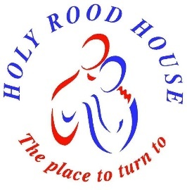
HOLY ROOD HOUSE

With Juliet House

CENTRE FOR HEALTH AND PASTORAL CARE
10 Sowerby Road, Thirsk, YO7 1HX 01845 522580
www.holyroodhouse.org.uk

BOOKING FORM FOR INDIVIDUAL GUESTS

Name/s: Title or preferred pronouns:
Address: Post Code:
Email address: Phone number:
Emergency contact (eg should you become ill during your stay):

If you would like to arrange for a one-to-one session during your stay please tick here _______
Please check the website (or contact us) and fill in the appropriate form for therapy or Spiritual Accompaniment.

Please contact our Programme Coordinator to confirm availability and then complete the following:
Purpose of visit / name of event:
Date of arrival: Date of departure:
If you are travelling by train we are a 30 minute walk from the station. We may be able to offer you a lift.
If you would like to see if we are available, please tell us the time your train is due:

Some of our bedrooms are ensuite, others are very close to a toilet and shower/bath.
Ensuite rooms are £5 more per person per room per night. Would you prefer ensuite? Yes / No

If your booking is for 2 people, would you prefer: Single Rooms / Twin Room / Double Room

Please tell us if we can make your stay more comfortable,
eg dietary requirements, accessibility issues, sensitivity to perfume or allergies.

We ask for a Non-Refundable Deposit of £50 per person to secure your booking.
In the event of cancellation, we would be pleased to transfer your deposit to another date.

Holy Rood House is funded by donations. Our current costings are on the website.
If you are able to offer higher donations these help us to cover our costs.
If you are a UK Tax Payer, please Gift Aid your donation. Form on website.

BACS PAYMENTS: 40-28-16 41227572 Reference: SURNAME & date of arrival (eg SMITH03Jan)

Cheques payable to: Holy Rood House Thank you!

Signed Date

