Booking Form: ‘Bearing Witness’
Please send this information to: enquiries@holyroodhouse.org.uk or post the information to Holy Rood House, 10 Sowerby Road, Thirsk, YO7 1HX

Name/s (both names if sharing a room)
Address
Telephone Email

RESIDENTIAL GUESTS (Mon 12noon until Thursday 2pm, full board)
Please state which type of bedroom you would prefer; the suggested donation is per person for the whole summer school:
- £430 (ensuite)
- £415 (shared bathroom or sharing a twin bedroom)
Please state any mobility issues and/or dietary requirements.

NON-RESIDENTIAL GUESTS (Refreshments included, no meals)
For each session we ask for £25 at time of booking.

Mon 2pm – 5pm | Introduction: Holding Space (Wahida Shaffi)
Tuesday 9.30am – 12.30pm | ‘Holding Space’ and ‘More than a statistic: Bearing Witness on the path to social justice’ (Wahida Shaffi/Paul Morrison)
Tuesday 2pm – 5pm | ‘More than a statistic: Bearing Witness on the path to social justice’ (Paul Morrison)
Wednesday 9.30am – 12.30pm | ‘Witnessing to Ableism in the Church’  (Revd Canon Timothy Goode)
Wednesday 2pm – 5pm | ‘Even the stones would cry out’  (Revd Dr Romola Parish)
Thursday 9.30am – 12.30pm | Plenary
We ask for full payment to secure your booking.
If you pay by BACS please let us know in your email or tick here: ___
BACS details - HSBC plc: Sort Code: 40-28-16 A/C no. 41227572
Centre for Health and Pastoral Care. Reference Surname 6JULY
Cheques payable to Holy Rood House
If you are a UK Tax Payer we can claim Gift Aid on your donation Y / N
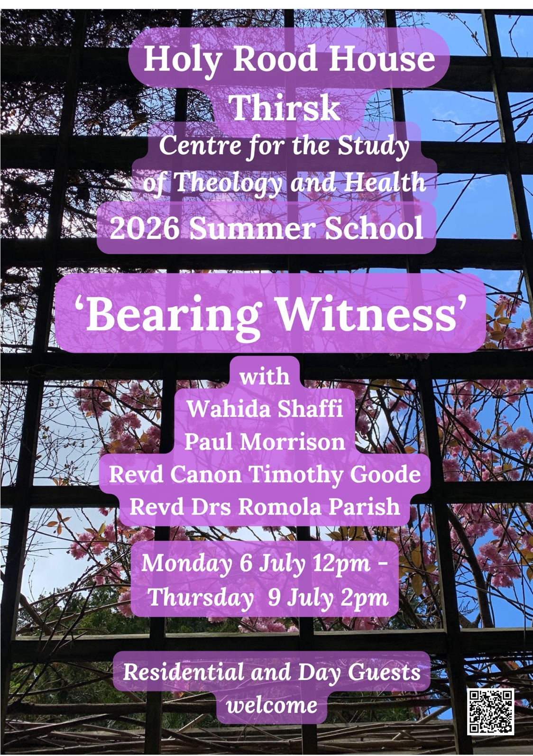
Holy Rood House Summer School 6-9 July 2026
‘Bearing Witness’
Each day will include presentations by people who are speaking from their own experience of ‘bearing witness’.

Wahida Shaffi (Monday pm/Tuesday am)
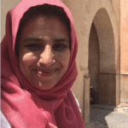
has over 20 years’ experience working with diverse communities from across the UK. She is a qualified chaplain, social worker, vocational assessor and trainer, and author of the book ‘Our Stories Our Lives: Inspiring Muslim Women’s Voices’. She completed her MA in international politics at the University of Bradford’s Department of Peace Studies and is the Founder of Holding Space – creating space for those engaged in the vital, often pressurised, and demanding work of building community, bringing people together across difference and seeking to nurture and implement values related to peace, justice, compassionate leadership.

Paul Morrison (Tuesday am/pm)
More than a statistic: Bearing Witness on the path to social justice
This session will look how people sharing their lived experience of poverty is transforming how churches, charities and even some policy makers are responding to the issue. Paul’s training is in data and science (and he loves a graph), but he will look at how it is story, narrative and relationship that is creating lasting change.
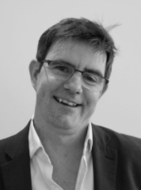
Paul grew up in Northern Ireland during the troubles. This experience led to a lifelong engagement with faith, politics, and social justice. Since 2010, Paul has served as a public issues advisor to the Methodist Church specialising in UK poverty and was also a director at the anti-poverty and foodbank charity Trussell until last year. Prior to this Paul designed vaccines before co-founding the public interest company to licence technologies developed during his postdoctoral studies. He works for https://jpit.org.uk/

Revd Canon Timothy Goode (Wednesday am)
‘Witnessing to Ableism in the Church’.
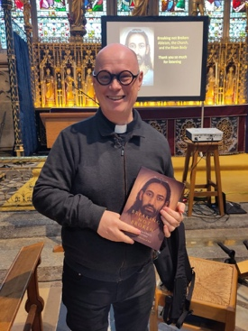
Witnessing to ableism in the Church is to name the ways in which Christian theology, practice, and structures have privileged an idealised norm of body and mind, often at the expense of those who do not conform to it. It is both an act of truth-telling and of hope, exposing exclusion while calling the Church to become a community shaped not by perfection, but by the wounded, risen body of Christ in whom all belong.
The Revd Canon Timothy Goode is Canon for Congregational Discipleship and Nurture at York Minster. A theologian, priest, and writer, his work focuses on disability theology, Christian anthropology, and the transformation of ecclesial life, worship, and heritage. Having lived with disability for over thirty years, he brings lived experience into sustained theological engagement with ableism in the Church, particularly as it has been shaped by post-Constantinian assumptions about power, perfection, and the idealised body.

Rev. Dr Romola Parish (Wednesday pm)
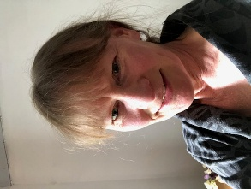
“Even the stones would cry out…” – a time of input incorporating creative reflection time.
Revd Dr Romola Parish is a former academic specialising in environmental change in mountains and deserts. She retrained as a lawyer and practiced environmental and planning law in London for 20 years. During this time she trained in traditional hand embroidery at the Royal School of Needlework and did a masters in Creative Writing at Oxford, followed by a second PhD in poetry and medieval hagiography. She is based in West Wales and is currently a curate in the Diocese of St Davids.
We will be exhibiting her creation ’Trees of Life’ during the Summer School: a number of textile tree ’sculptures’ that inspire contemplation of the connection between the human race, the Creation and God. They reflect both resourcefulness and resilience as well as the fragility of the world around us and encourage us to see God in all things.

