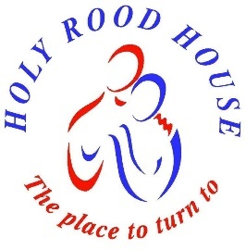
HOLY ROOD HOUSE

With Juliet House

CENTRE FOR HEALTH AND PASTORAL CARE
10 Sowerby Road, Thirsk, YO7 1HX 01845 522580
www.holyroodhouse.org.uk

APPLICATION FOR SPIRITUAL ACCOMPANIMENT

Name. Title or preferred pronouns
Address
Post Code
Email address Phone
Have you had spiritual accompaniment before ? Yes / No
Do you have any preference for a male or female accompanier? Male / Female / Don’t mind
Would you prefer to meet with a member of the clergy? Yes / No / Don’t mind
Please tell us something of your spiritual journey, this will help us as we identify someone to accompany you

When are you free to meet with your Accompanier? We usually suggest monthly meetings or less frequently
Mondays / Tuesdays / Wednesdays / Thursdays / Fridays / Saturdays
Morning / Afternoon / Evening

Holy Rood House is funded by donations. Those who receive Spiritual Accompaniment are invited to support our work by paying between £30-£60 per session. Wherever possible please Gift Aid your donation.
Thank you!

Signed: ---------------------------------------------------------- Date: -----------------------

